COMPLAINTS

& CONCERNS

POLICY

APPROVAL BODY – CMT / SUPPORTING LEARNING MANAGEMENT GROUP

PERSON RESPONSIBLE – DIRECTOR OF STUDENT SERVICES

DATE OF LAST REVIEW

2013

DATE OF NEXT REVIEW

2015

High Quality Education in a Caring Environment”

COMPLAINTS AND CONCERNS: POLICIES AND PROCEDURES

Index:

Complaints Policy- Page 2

Complaints Procedures

Introduction Page 5

Concerns Procedure Page 6
Complaints Procedure Page 6
Complaints against the Corporation Page 8

Complaints Form Appendix 1
Concerns Form Appendix 2

COLLEGE POLICY ON COMPLAINTS

- The College is committed to ensuring the high quality of its provision and the satisfaction of all those who use the College or who are members of its wider community. Concerns and complaints are welcomed as a means to ensure this commitment is met. The Principal takes a personal interest in the resolution of every complaint.

- The College aims to

- have a clear, easily accessible Complaints Procedure which is understood and accepted as a Code of Practice by all members of the College community, and which operates consistently across the organisation;

- deal with formal complaints fairly and efficiently, with an acknowledgement and an initial response made within a maximum period of ten working days of receiving the complaint;

- maintain confidentiality wherever reasonable;

- compile a recording system for all formal complaints which is reliable and comprehensive. This informs the appropriate managers so that improvements can be made in the future;

- The College defines

- concerns as issues where a person wishes to register unease about a situation without (at least initially) proceeding to make a formal complaint. Concerns will normally be raised with, or passed to, the appropriate manager;

and

- complaints as issues which are formally documented, with a written record of the complaint and a written response to the complaint. All complaints are reported to the Principal.

Sources of Complaint

Complaints could be made by any member of the public, visitor or college customer. The latter are likely to be:-

- full time students

- parents of full time students

- staff (also see governance procedure)

- members of the Corporation

Dealing with Complaints

Details of how complaints and concerns may be made are included in the College Complaints and Concerns Procedure.

The College ensures that, for every complaint,

- a complaint form is completed;

- initial responses are made within ten working days;

- under normal circumstances, the complaint is fully investigated and resolved to the complainant’s satisfaction within four weeks of the receipt of the complaint;

- the complaint form, together with appropriate documentation (including summary of action taken and response made) is retained in the Principal’s PA’s office;

Further Referral

Complainants who are not satisfied by the College’s response can complain to the Education Funding Agency. (Please refer to Annex B).

Whistleblowing Procedure

Staff who suspect fraud, financial irregularities, corruption, bribery, dishonesty, acting contrary to the staff and Corporation Codes of Conduct, criminal activities, or failing to comply with a legal obligation, a miscarriage of justice, or creating or ignoring a serious risk to health, safety or the environment, should follow the College’s Whistleblowing Procedure. Copies are available from the Clerk to the Corporation and on the Intranet.

Complaints about the Principal or Corporation

Complaints about the Principal or the Chair of the Corporation should be made via the Clerk of the Corporation. Complaints about the Corporation should also be made via the Clerk of the Corporation.

Revision of policy

This policy is to be reviewed by the Corporation 2 years from the date of first approval

COMPLAINTS AND CONCERNS PROCEDURES

Introduction - Concern or complaint, how do you choose?

- Whenever you have a problem, you should first see the member of staff in charge of that area and discuss the problem with them.

- If you are still not happy with the response given, or the situation has got worse, you should fill in a concern form at reception. If this problem is with catering you should fill in their comments form situated in the canteen.

Concern – minor issues about problems with bus services, unease about a situation e.g. state of toilets.

These will be passed on to the appropriate staff, who will look at and be available to talk about your concern and a summary of action will be returned to you promptly.

- If you do not feel your concern has been treated seriously, the response you received did not satisfy your initial concern, or the situation has got worse you should fill in a complaint form.

Complaint – Significant problems with college services provided, e.g. unfair treatment by members of staff, problems limiting academic performance, e.g. being entered for the wrong exam, or a problem endangering student health and safety, e.g. blockage of fire escapes.

This is a formal complaint procedure where the first step is to fill in a form at reception. The Principal takes a personal interest in complaints and confidentiality is always kept wherever possible. An initial acknowledgement should be received within 10 days, and your complaint should be fully investigated within 4 weeks.

Procedures

1. CONCERNS

a. Those wishing to raise concerns may do so directly to the managers responsible or simply by contacting College Reception who will ensure that the concern is passed to the appropriate manager.

b. In general, a full-time student with concerns about his/her programme of study should contact his/her Senior Tutor, whilst part-time (adult) students should contact the Adult Programme Manager.

c. All other areas of concern should be passed to the manager responsible (see Annex A), sometimes by completing a form (see Appendix 2).

d. In every case, the concern will be treated seriously and, wherever possible, to the satisfaction of the person concerned. Where a situation cannot be resolved, the manager involved will suggest the matter is passed to a more senior manager and/or encourage the completion of a complaints form. A person raising a concern may at any time choose to lodge that concern as a complaint.

e. Summary:

- Concerns forms are available from Reception (see appendix 2).

- Reception staff pass on completed Concern form to appropriate member of staff (usually a senior member of staff) on a daily basis.

- Senior manager records action on Concern form (duplicate form).

f. Return Response

- One copy to Principal

- One copy to student via register

- Principal collates termly report to Student Forum and CMT.

2. COMPLAINTS

- On receipt of a complaint, a complaint form is raised- see Appendix 1.

- The complaint form is passed to the Principal’s PA within 24 hours.

- The Principal will initiate an investigation via the appropriate Senior Manager.

- The Senior Manager investigates the complaint and reports back initial findings and any action taken to the Principal within five working days, using the appropriate section of the complaint form.

- The Principal responds to the complaint with initial findings within ten working days.

- If the complaint is not resolved, the Principal conducts a more detailed investigation.

- The Senior Manager reports back detailed findings to the Principal within a further eight working days using the appropriate section of the complaint form.

- The Principal reports to the complainant within four weeks of the complaint. Most complaints are resolved by this stage. If necessary, dialogue will continue until resolution.

- If the Complainant is not satisfied with the response from the Principal, they may lodge an appeal, in writing, to the Principal.

- Complaints unresolved after three months will be reported by the Principal to the Chair of the Corporation.

- Procedures are applied fairly and consistently across the college and over a period of time;

- An annual report on complaints received is provided by the College Corporation (Board of Governors).

- The College has a Whistleblowing Procedure for use by employees who suspect serious malpractice, fraud or similar. Copies are available from the Clerk to the Corporation or are published on the Intranet.

3. COMPLAINTS AGAINST THE CORPORATION

- A complaint against the Corporation, a member of the Corporation or the Clerk to the corporation may be made by an individual, business or an organisation. However, complaints by members of staff are to be dealt with in accordance with the College Grievance Procedure and by students in accordance with the College Complaints Procedure.

- Complaints against the Corporation or a member of the Corporation should preferably be made in writing and addressed to the following:

The Clerk to the Corporation
City of Stoke-on-Trent Sixth Form College
Leek Road
Stoke on Trent
Staffordshire
ST4 2RU

- The complainant will be expected to state clearly the nature of the complaint and if appropriate provide copies of any related documentation.

- The Clerk to the Corporation will:

  - acknowledge receipt of the complaint without delay

  - investigate the complaint

  - endeavour to provide a response to the complaint within ten working days and if this is not possible provide the complainant with an interim statement

  - maintain a log of events concerning the complaint.

- The written response of the Clerk to the Corporation will include details of any arrangements for pursuing the matter with an independent body (e.g. the Secretary of State for Education and Employment and the Education Funding Agency.

- The Clerk to the Corporation will keep the Chair informed of the situation, and will provide the corporation with a written statement of the nature of the complaint and the response at the next meeting. Such a report shall be circulated to members within ten working days of the response of the Clerk to the complaint so that members are aware of the situation.

- When carrying out an investigation on a complaint against the Corporation or an individual member of the Corporation the Clerk to the Corporation will have the authority to refer issues to the Corporation’s auditors (external and/or internal) or other appropriate advisors.

- A complaint against the Clerk to Corporation shall to be forwarded to the Chair of the Corporation for investigation and response. Letters for the attention of the Chair of the Corporation should be marked ‘Strictly Private and Confidential’ and addressed to:

The Chair of the Corporation
The City of Stoke on Trent Sixth Form College
Leek Road
Stoke on Trent
Staffordshire
ST4 2RU

- The Clerk to the Corporation is to maintain a record of all complaints made to or about the Corporation and their outcome. The clerk is to report annually to the Corporation on the nature and disposal of such complaints.

Annex A

COMPLAINT RELATING TO | MIDDLE MANAGER | SENIOR MANAGER
Curriculum subjects or areas | Head of Subject or  Co-ordinator (see list) | Relevant Head of Faculty (HoF)
Programme of study | Senior Tutor | Director SS
Bus services | Receptionist | Ditto
Catering (including vending machines) | N/A | Director F&R
Cleaning | Estates and Site Manager | Ditto
Health & Safety | Health & Safety  Co-ordinator | Ditto
Building | Estates and Site Manager | Ditto
Student behaviour | Senior Tutor | Director SS&G
Conduct of staff | Line Manager | Principal
Examinations | Funding manager | Director of Planning & Operations
Corporation | See Complaints about the Corporation | See Complaints about the Corporation
Clerk to the Corporation | See Complaints about the Corporation | See Complaints about the Corporation

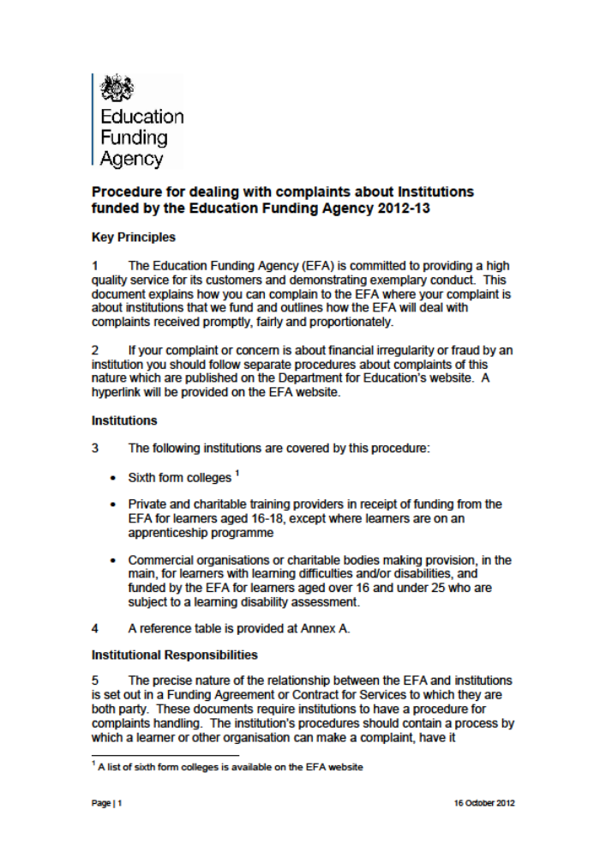

APPENDIX 1
COMPLAINTS FORM

For your complaint to be investigated you must include your full name
(The college is not able to investigate anonymous or malicious complaints)

Guidance on completing the form:

- Please complete Parts A & B
- Form to be returned by Complainant to Reprographics
- Reprographics to forward complaints form to Principal’s PA for action

What happens next?

- You will be contacted about your complaint
- Parts C & D to be completed by relevant member of staff or Senior Manager
- Form to be filed in Principals Office

PART A
Full Name of person making complaint:
Contact details (Telephone number or e-mail):
If a current student state Tutor Group:
Student name (If different):

PART B
WHAT IS YOUR COMPLAINT (Attach more information to this form if you wish or require more space)

For Office Use Only:
Date Complaint Received:
Date Complaint Received By Reprographics:
Date Forwarded to Principal’s Office:
Acknowledgement given to person making complaint and date:
(Verbally / Written)

Name of person investigating complaint:

PART C
ACTION TAKEN & RESPONSE LOGGED (please complete additional sheet if required)
Date | Action or Response Given | Action Taken By (Name)

PART D
COMPLAINT SUMMARY RESOLUTION OR RESPONSE
(please complete additional sheet if required)
Date | Action or Response Given | Action Taken By (Name)

For Office Use Only:
Signed:
Complainant Informed of Action or Resolution:
(Verbally / Written)
Date:

APPENDIX 2
CONCERN FORM

For your complaint to be investigated you must include your full name
(The college is not able to investigate anonymous or malicious concerns)

PART A
Full Name of person raising concern:

Contact details (Telephone number):

If a current student state Tutor Group:

Student name (If different):

PART B
AREA OF CONCERN (e.g. Transport, Facilities, Toilets, Catering)

For Office Use Only:

Date Concern Received:
Concern Received By Reprographics (Name):
Forwarded to Principalship (Name):

PART C
FEEDBACK GIVEN ON OUTCOME OR RESOLUTION (If deemed appropriate)

Signed:
Date:

