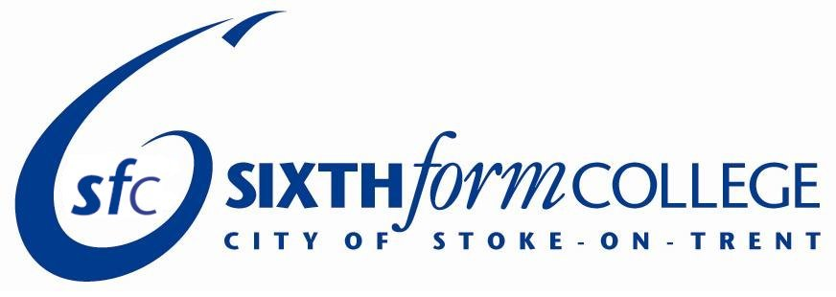

ROLE SUMMARY

PARENT GOVERNOR

TERM OF OFFICE: September 2020 – July 2022

LOCATION: City of Stoke on Trent Sixth Form College

ROLE PURPOSE

The Local Governing Body of the City of Stoke-on-Trent Sixth Form College is a sub-committee of the Potteries Educational Trust and has three key functions:
- To ensure that the College has a clarity of vision, ethos and strategic direction
- To oversee the financial performance of the College and make sure its money is well spent
- To hold the Principal and senior leaders to account for the educational performance of the College and its students and the performance management of staff

PARENT GOVERNORS ARE EXPECTED TO:

- Attend an Induction meeting and other induction activities including becoming familiar with the data necessary to monitor College performance
- Prepare for, attend and fully participate in meetings of the Local Governing Body (usually four meetings per academic year)
- Attend training and information sessions beneficial to the role (usually two per academic year)
- Participate in a range of activities in order to assist in triangulating information received at meetings, such as student shadowing; quality boards; mock interviews for university places; meetings with staff; College events; and becoming a link governor for a specific area or theme

- Participate in an annual review to discuss input, conducted by the Chair or Vice Chair of the Local Governing Body
- Maintain a professional approach as set out in the College Code of Conduct, including acting in strict confidence
- Act in the best interest of the students and other stakeholders

SKILLS AND EXPERIENCE:

- The ability to challenge and ask probing questions
- The ability to contribute to formal meetings
- A willingness to learn about and understand data relevant to the educational and financial performance of the College
- An understanding of aspects of the local community
- An interest in young people and their aspirations
- The ability to reflect on matters from the perspective of parents and students and act in the best interests of stakeholders
- A belief in behaving in a professional manner and keeping to the College code of conduct, including acting in strict confidence

