Date: Monday 18 September 2023

Dear Resident

Important information regarding Lower Bethesda Street Temporary closure

As part of the Transforming Cities Fund scheme, we need to close Lower Bethesda Street in two sections to construct a new carriageway, creating a wider pavement and cycle lane.

When will this work take place?
We will close Lower Bethesda Street on Monday 2 October, for approximately three months, with the traffic management remaining on-site at all times for safety reasons. Our working hours will be Monday to Friday between the hours of 7.30am and 5.30pm. Please note that all our planned roadwork may be subject to change due to weather conditions or unforeseen circumstances.
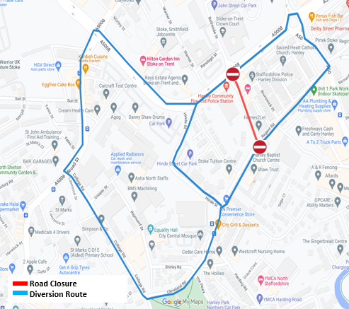
How will this work affect me?
Parking for residents on Lower Bethesda Street will be relocated to Jasper Steet, with temporary parking spaces allocated. During this time, to enter Jasper Street, you will need to use Regent Road
A signed diversion route will be in place during this time. Depending on motorists’ travel direction the Diversion route will utilise; Potteries Way, Broad Street, College Road, Hinde Street, Regent Road, and A50 Lichfield Street. Motorists should allow extra time for their journeys.

How will we minimise disruption?
We are closing Lower Bethesda Street in two sections and will maintain access to all properties using a temporary footpath within the traffic management setup. Noise levels will be low, and engines will be switched off when not in use. To help maintain the flow of traffic, there may be times we install temporary traffic lights.

For further information, please get in touch with your local Public Liaison Officer, Clare Rusbridge, at stoketcf@gallifordtry.co.uk

